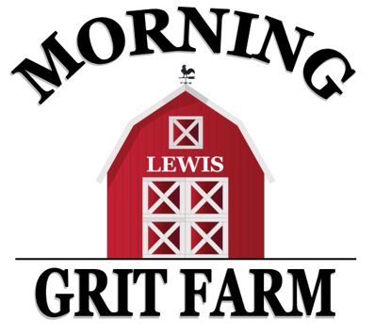
Morning Grit Farm, LLC Party Pricing
All parties are max of 30 people (including adults.)
Additional fee of $10 per person up to 40 total guests may be added.
All guests must sign waiver before participating in any farm activities.

Barnyard Bash Basic: $250 2 hour party includes:
-miniature ponies guests can pet, brush and lead around our colorful obstacle course
-use of barn amenities, refrigerator, solid color table ware (table cloths, forks, spoons, napkins), water/ice -banner, decorated backdrop/chair for opening gifts -Lil’ Buckaroo Corner” (farm toys, books, puzzles) -wrangler rope throw and cowpoke ring toss games -petting zoo in barn with mini animals -access to Morning Grit Tree house -open soccer/sports field

Barnyard Bash Deluxe: $325 2 hour party includes all the basic package plus:
-miniature horse cart rides -1 decorated pony -tug of war, nature hunt, sack races -horseback rides (mini or big horse)

Barnyard Bash Supreme: $425 2.5 hour party includes all the above two packages plus:
-2 horses for horseback rides (mini and/or big) -table décor -bounce house -fire pit/s’mores station (best for evening parties; hot weather and/or wind permitting)

Pony Party Theme Choices: Pony will have decorated mane, tail, and hooves. Choose from the following theme options or contact us for special theme requests:
-Cowboy/Cowgirl -Rainbow -Barnyard Animal
-John Deere Tractor -Dinosaur -Unicorn
-Pony Ballerina -Knight/Hunting/Target -Toy Story
-Pony Princess* -Outdoor Adventure -Super Hero
*Ultimate Princess Party Add On: $130 Add on a real princess to any package above from our partner, Happily Ever After Parties, carriage rides, and another 30 min. for the Ultimate Princess Party!

Party Add-Ons: Add on to any package, we take care of it all; you just bring the kids that day!

Party Invites: Personalized invites from our etsy partner, InkFloydDesign! You pick design, we order for you!
$9 digital, 5x7 printable invite $5 facebook event cover invite
Cupcakes or Cookies: Special pricing with our partners, September Moon Cupcakery and Tuffy Ray’s Bakery!
$60 for 30 regular cupcakes $70 for 30 specialty cupcakes $70 for 30 custom decorated cookies
A $50 deposit is due at time of reservation. The remaining balance is due the morning of the party. We look forward to working with you to plan a fun, memorable, farm party to celebrate any special occasion!!

