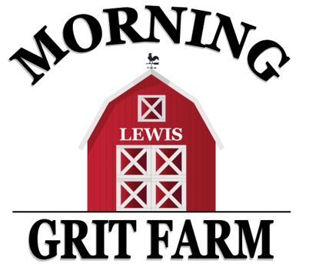
Morning Grit Farm, LLC Party Pricing
All parties are max of 30 people (including adults.)
Additional fee of $10 per person up to 40 total guests may be added.
All guests must sign waiver before participating in any farm activities.

Barnyard Bash Basic: $225 2 hour party includes:
-3 miniature ponies guests can pet, brush and lead around our colorful obstacle course
-use of barn amenities, refrigerator, solid color table ware (table cloths, forks, spoons, napkins), water/ice -banner, decorated backdrop/chair for opening gifts -Lil’ Buckaroo Corner” (farm toys, books, puzzles) -two games of your choice (choose from list below) -interactions with farm animals -access to Morning Grit Tree house -open soccer/sports field

Barnyard Bash Deluxe: $295 2 hour party includes all the basic package plus:
-miniature horse cart rides -1 decorated pony -2 more games (4 total) -horseback rides (mini or big horse)

Barnyard Bash Supreme: $395 2.5 hour party includes all the above two packages plus:
-mini horseback rides and big horseback rides -all games/activities (6 total) -table decor
-bounce house -fire pit/s’mores station (best for evening parties; hot weather and/or wind permitting)

Game Choices: (All games are property of the farm; pricing is for set up and use of game.)
-Archery -Cowpoke Ring Toss Game -Wrangler Rope Throw Game
-Tug-of-war -Sack Races (4 sacks, several game options) -Morning Grit Farm Nature Hunt
Pony Party Theme Choices: Pony will have decorated mane, tail, and hooves. Choose from the following theme options or contact us for special theme requests:
-Cowboy/Cowgirl -Rainbow -Barnyard Animal
-John Deere Tractor -Dinosaur -Unicorn
-Pony Ballerina -Knight/Hunting/Target -Toy Story
-Pony Princess* -Outdoor Adventure -Super Hero
*Ultimate Princess Party Add On: $130 Add on a real princess to any package above from our partner, Happily Ever After Parties, carriage rides, and another 30 min. for the Ultimate Princess Party!

Party Add-Ons: Add on to any package, we take care of it all; you just bring the kids that day!

Party Invites: Personalized invites from our etsy partner, InkFloydDesign! You pick design, we order for you!
$9 digital, 5x7 printable invite $5 facebook event cover invite
Cupcakes or Cookies: Special pricing with our partners, September Moon Cupcakery and Tuffy Ray’s Bakery!
$40 for 30 regular cupcakes $50 for 30 specialty cupcakes $70 for 30 custom decorated cookies
A $50 deposit is due at time of reservation. The remaining balance is due the morning of the party. We look forward to working with you to plan a fun, memorable, farm party to celebrate any special occasion!!

